Project Design Phase-II Technology Stack (Architecture & Stack)

|  |  |
| --- | --- |
|  |  |
| Team ID | PNT2022TMID10090 |
| Project Name | AI -Intelligent Vehicle Damage Assessment and Cost Estimation for Insurance Companies |
| Maximum Marks | 4 Marks |

# Technical Architecture:

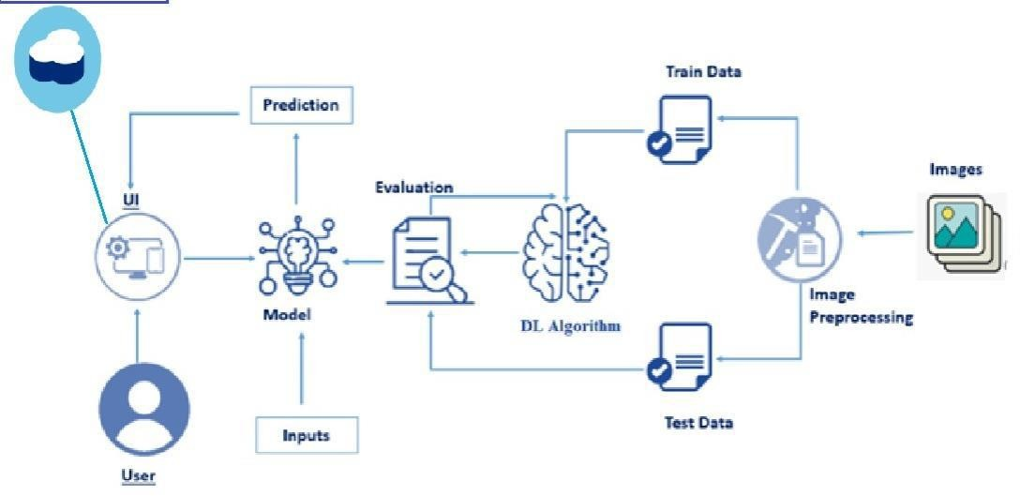

### 

      

Claims determined

to be 1’ast tracked

Proper coverages upened Elf iJispection rh Us uf damage and reserves set, sending link sent to uploaded downstream noMces to customer

finanoiaTs

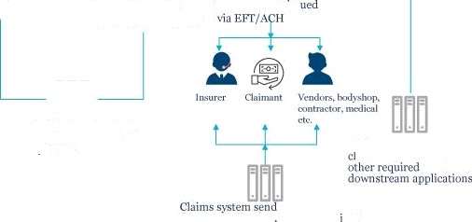

6xtimate cum plete either Ly computer Psion or *desk* appraiser

Claims ya›'nien

automatically lss



with policy system to retrieve polio- data, in force status etc



- ’ -

Resernn ng data set

Ph otor a ad csriniaic

thins 6y5tTe s0nds final

## aindata to W' and

pojmlent info to finn nce application U\V sent cla ms infu to be utilized fur renewals





# Table-1: Components & Technologies:

|  |  |  |  |
| --- | --- | --- | --- |
| **S.No** | **Component** | **Description** | **Technology** |
| 1. | User Interface | How user interacts with application e.g., Mobile Application | HTML, CSS, JavaScript. |
| 2. | Application Logic-1 | Logic for a process in the application | Python |
| 3. | Application Logic-2 | Logic for a process in the application | IBM Watson STT service |
| 4. | Application Logic-3 | Logic for a process in the application | IBM Watson Assistant |
| 5. | Database | Data Type, Configurations etc. | MySQL, Deep learning |
| 6. | Cloud Database | Database Service on AI | IBM Cloudant DB |
| 7. | File Storage | File storage is more. | IBM Block Storage or Other Storage Service or Local Filesystem |
| 8. | AI Model | Purpose of AI Model is for estimating the cost of the damaged vehicle. | IBM AI Platform |
| 9. | Infrastructure (Server / Cloud) | Application Deployment on Local System / Cloud Local Server Configuration:  Cloud Server Configuration : | Cloud Foundry, etc. |